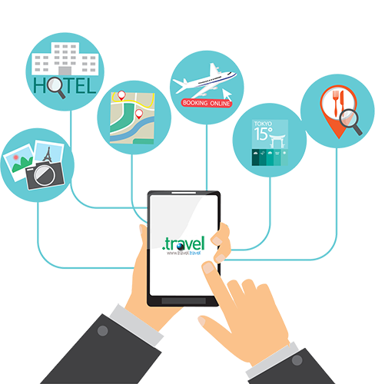

2021

Name: Lutho

Surname: Tofile

Subject: Computer Application technology

School: School of Hope

Topic: Unlocking a resilient future

# Table of content

Contents

Table of content 2

Table of Figures 3

Introduction 4

Task definition 5

What is the current situation and the purpose of this investigation? 5

What will be the focus of investigation? 5

How will I go about the investigation considering all PAT requirements? 5

Who is the target audience? 5

Focus Question? 6

Research Questions 6

Findings 7

Evaluating sources: 17

Summary of each source: 19

Conclusion 21

Bibliography 22

Folder structure 23

## 

# Table of Figures

Table of content 2

Table of Figures 3

Introduction 4

Task definition 5

Findings 7

Conclusion 20

Bibliography 21

# Introduction

Technology has played a big role in the tourism sector. Technology helped improve efficiency, services, reduce cost, improve safety of customer, and enhanced the traveling experience of customers. The sector benefits a lot from technology by enhancing its communication, and productivity.

However, tourism sectors have been hard hit by the pandemic due to many infections. The infections are caused by many things including tourism services which were regarded as the main hotspots and spreaders of the virus. Since many people use the tourism services to travel around the world. The virus easily spreads throughout countries due to many travelers from different countries.

The world is driven by technology and tourism, especially in traveling, People need these sectors to travel around the world. However, tourism has been at a standstill for a long time since the virus has started. The sector has lost financially due to the lockdown effects that stopped traveling. A lot of services stopped, and many industries were not operating:

Airlines were suspended and many people were trapped in other countries, there couldn’t move until the infection rates were easing.

Some public transports had to stop operating, people were making use of their cars and those who had no cars were struggling to get transport.

But since the lockdown has eased some of the sectors are back on operating including the tourism sector but there are strict rules that need to be followed to prevent infection rates from rising

The research is to find out how the industry can overcome all these challenges using technology and what strategies were used by the industry involving technology to overcome these challenges. And how did there operate under the conditions of the virus using technology? The Pat consists of 3 phases each phase has the data collected and organized on the research. Phase 1 consists of the first report, the first report is the first graph of the research, followed by phase 2 which involves a lot of office tools for analyzing the data including a Database and a Questionnaire. Phase 3 is the final report of the PAT, this phase is the final graph which is the presentation of the whole research.

# Task definition

## What is the current situation and the purpose of this investigation?

## The travel and tourism sector are one of the most affected sectors during this pandemic. It is because traveling is the main cause of spreading the covid-19 virus, and it’s the reason why the virus has spread to many countries across the world. I want to provide the tourism sector with information on how there can operate during the pandemic using technology.

## What will be the focus of investigation?

## My investigation is to advise the sector and provide them with strategies on how there can operate without spreading the virus. I want to provide them with technology tools that can be helpful, such as e-ticket for airlines, etc. I want to show them how digital technology can prevent Hotel, Airline staff, guests from spreading the virus in hotels, airports, train stations, and more. I want to teach them skills there can use to prevent the impact of covid-19.

## How will I go about the investigation considering all PAT requirements?

## I will use the resources and skills that I have such as being able to use the internet, read articles to get valuable information, the technology skills I have which I find very helpful to many sectors that I have assisted. I will gather information strategies from experts all over the world using online tools like Google, Facebook, etc.

## Who is the target audience?

The group of people that I am targeting are the tourism enthusiast and the tourism sector.

## Focus Question?

How can Travel and Tourism sector use technology for continuous operations in this time of the pandemic?

## Research Questions

1.What new technologies will the airlines introduce during the pandemic for air travelers?

2.How was the accommodation sector able to use technology to combat COVID-19?

3.Was the use of E-tourism sustainable for tourist during the pandemic?

4.What technology tools are appropriate for use in hotels

5.how can tourist book accommodations using technology?

6. How can railway companies use technology to prevent the spread of the virus on trains?

7.What are the strategies that hotel shops, lodges can use to prevent covid-19 using technology?

8. What is the impact of covid-19 on the public transport sector?

9.Which technology tools are sectors using to combat covid-19

10.How Satellite Technology could potentially save SA Tourism?

# Findings

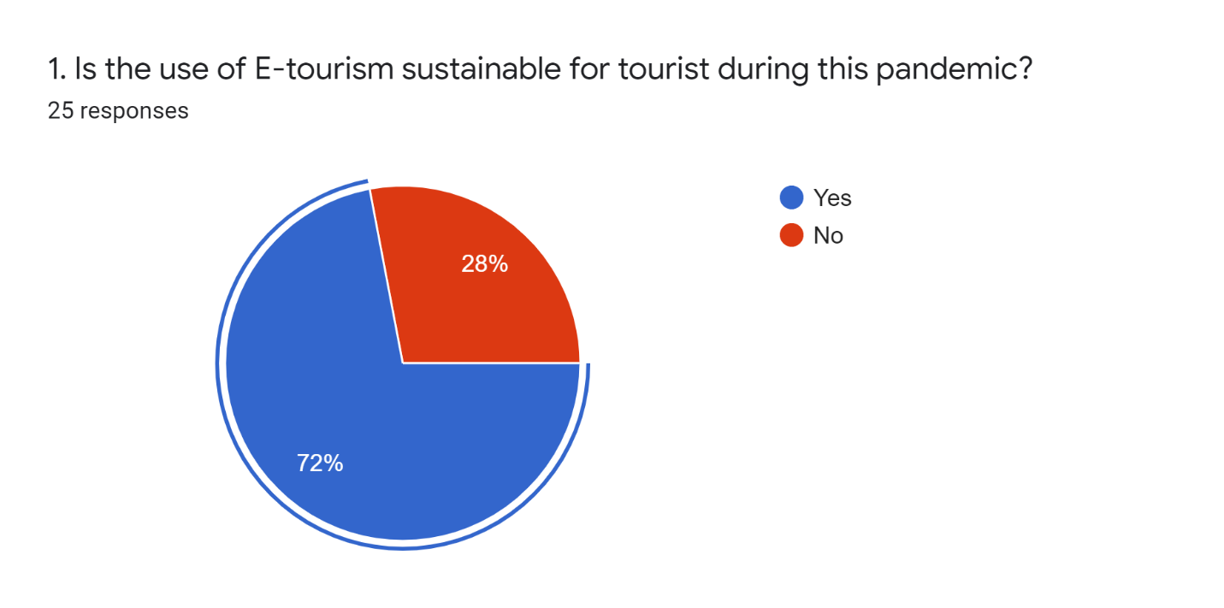

E-tourism makes travel easy for travelers by providing tourism with various tools that make the best traveling experience

The use of E-tourism has become sustainable during this pandemic, the graph shows **72%** of people agreed and **28%** of them disagreed. This shows that most people are sustainable with E-tourism and few of them are not. Most of them agree with sustainability because during this pandemic E-tourism is the safest way to enjoy travel. Tourists can explore top tourist attractions while sitting at home with the use of online services like trivago. Bookings can be done online to avoid any physical contact with other people and reduce ticket lines that can creates a lot of crowds etc.

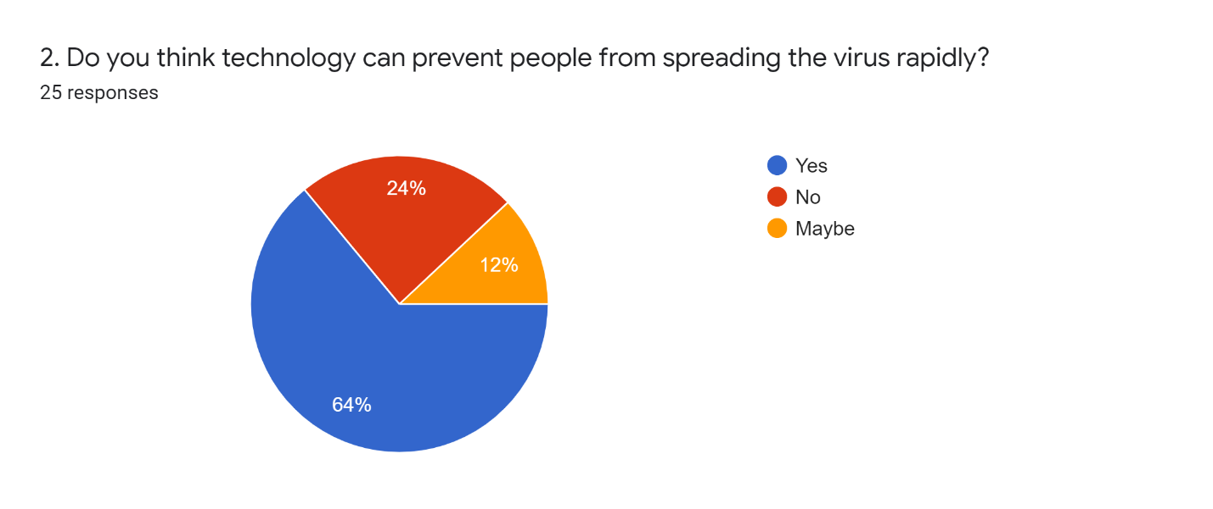

Technology has been helping a lot in the sector, it makes things easy for the industry in many ways. It is used in almost everything from accommodations, airlines, hotels, etc.

The research was conducted to see if technology can prevent covid-19 from spreading, the research was a questionnaire given to 25 people. Of the 25 people, **64%** of the people say technology can prevent the virus from spreading, but only **24%** of them disagree with that fact, and **12%** of them were not sure about that. This shows that technology can prevent the virus by **64%** according to this survey. But technology is not that accurate on preventing the virus because **24%** of the people say no it cannot prevent the virus and **12%** of them are not sure.

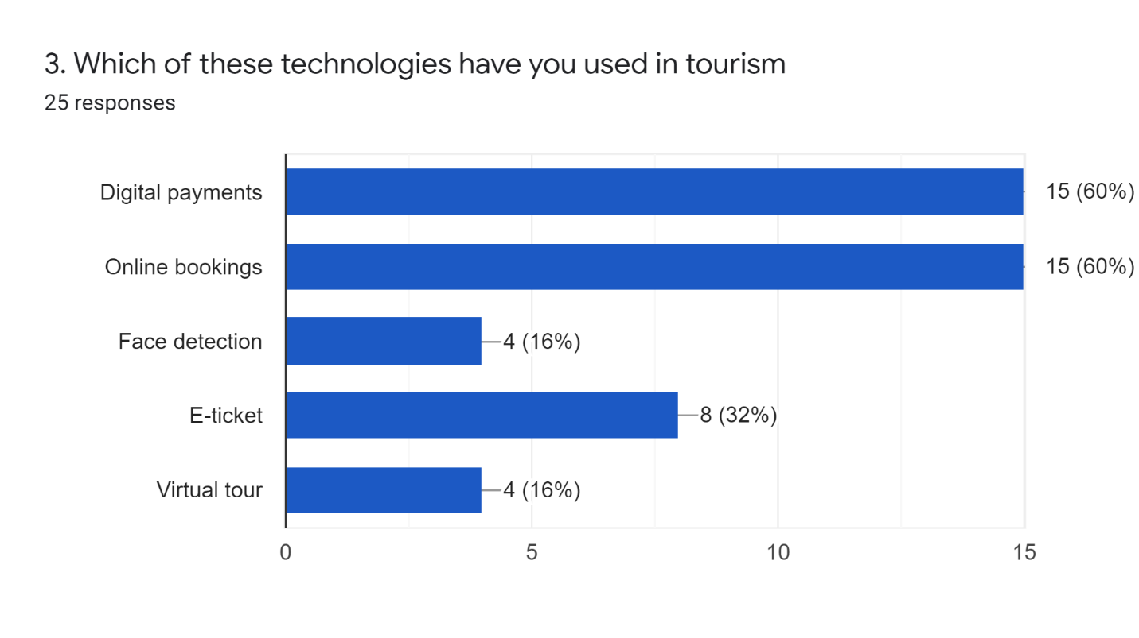

The following technologies have been helping a lot in the sector recently. From making traveling easy to boosting and maximizing the safety of traveling during this harsh time of the pandemic. Many tourists love these technologies, there say it makes the best of travel experience especially during this harsh time of

This bar graph shows statistics of the following technologies used in the tourism industry. These statistics are based on the use of technologies such as Digital payments, Online bookings, Face detection, E-ticket, Virtual tour. According to the percentages, **60%** of people have used Digital payments and **60%** have used Online booking while **16%** have used Face detection and only **32%** have used E-ticket and **16%** have used Virtual tours.

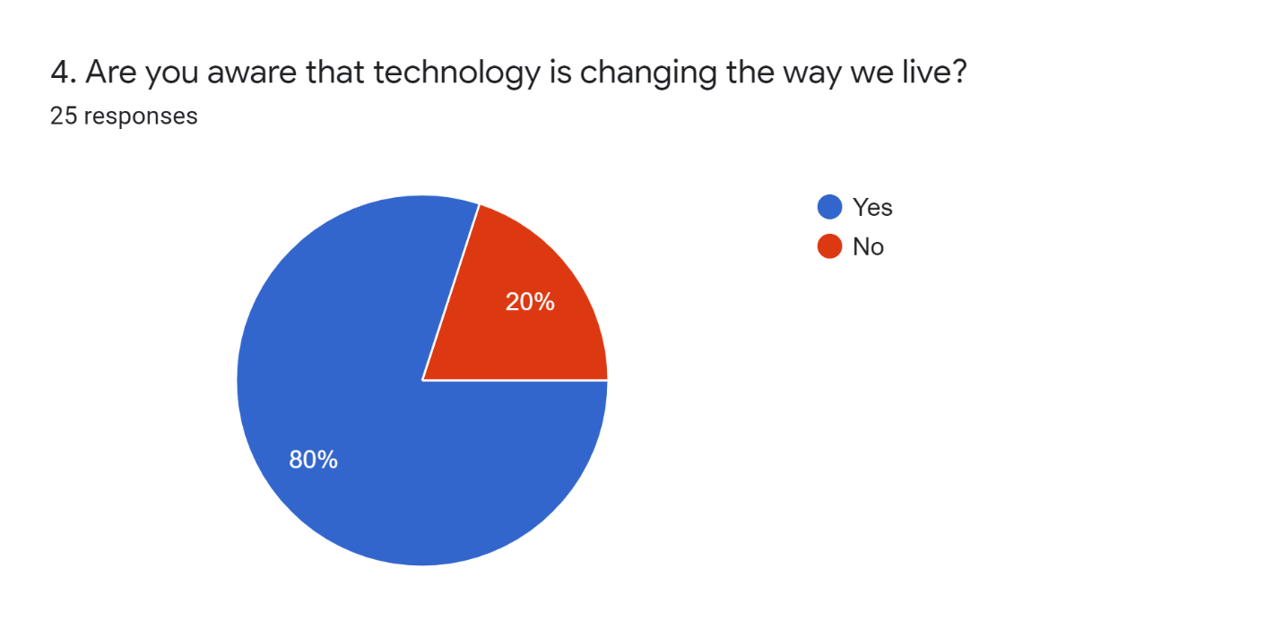

The survey was made to see if people in the tourism sector are aware of technology

**80% of the people said Yes**

**20% of the people said No**

This shows that most people are aware that technology is changing the way we live. It’s clear because technology is making our lives easy with innovations. By now everyone should be aware that technology is changing our lives, but some of the responses are not aware, **20%** of them said there are not aware. Technology is useful these days, it's used in almost every sector and is improving the status and the productivity of many sectors including the tourism sector itself.

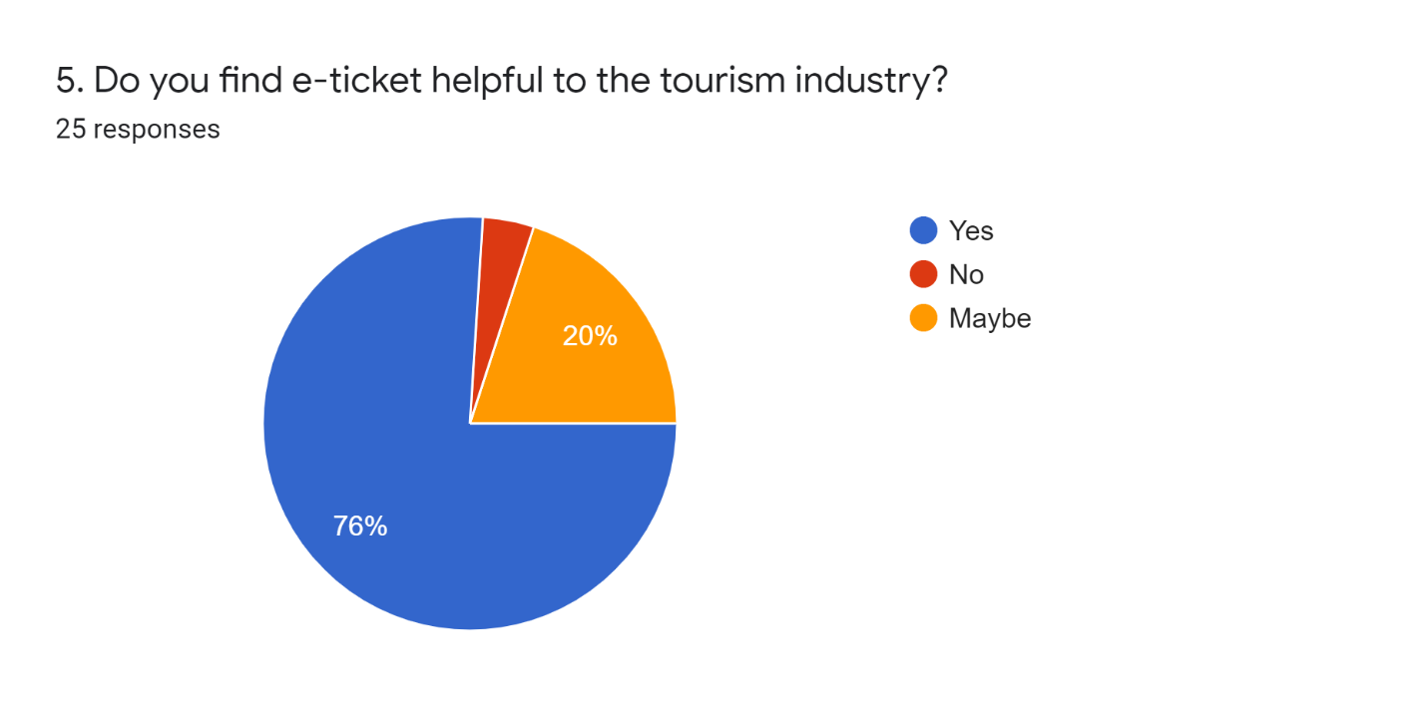

E-ticket is one of the innovative ways of traveling that was introduced in the late 90s. It is a traveling ticket in a form of an electronic document used for almost all traveling. It's safer than a physical ticket and it's safer to keep as it doesn’t get lost or damaged by water or something.

It is very helpful to the industry in many ways especially in fighting the covid-19 virus. E-ticket is an innovative way to travel that improves the standard and safety of traveling during this pandemic. It has made things easy for the industry by cutting ticket lines and reducing infection rates that increased dramatically.

**76%** of people said **Yes.** They find E-ticket helpful to the tourism industry

**4%** said **No** they don’t agree

And **20%** of them said **Maybe.** This group of people was not clear about the E-ticket

.

Appendices:

Research questions and Source table:

| **N0** | **CATEGORY**  **(Heading –** *minimum 3)* | **QUESTION** | **LEVEL OF QUES**  **(1, 2, 3, 4)** | **TYPE OF SOURCE**  **(Web site/ book/ magazine/ questions to people)** | **BIBLIOGRAPHICAL INFORMATION** | |
| --- | --- | --- | --- | --- | --- | --- |
| **1.** | Solutions | What new technology will the airlines introduce during the pandemic for air travelers? | 1 | Website | **Name of website-** | Airport Technology |
| **Name of web page** | Technology for airport operations post-covid-19 |
| **URL** | [Technology for Airport Operations Post-Covid-19 - Airport Technology (airport-technology.com)](https://www.airport-technology.com/contractors/consult/tav/pressreleases/technology-airport-operations-post-covid-19/) |
| **Author/**  **Organisation/**  **publisher** | TAV Technologies |
| **Date created** | 15 June 2020 |
| **Date accessed** | 21 April 2021 |
| **2.** | Problem | How was the accommodation sector able to use technology to combat COVID-19? | 3 | Website | **Name of website-** | Tsogo Sun |
| **Name of web page** | Covid-19 Health and Safety |
| **URL** | <https://www.tsogosun.com/covid-19-safety> |
| **Author/**  **Organisation/**  **publisher** | TSOGO SUN HOTELS |
| **Date Created** | 17 June 2021 |
| **Date accessed** | 21 June 2021 |
|  |  |
| **3.** | Problem | Was the use of E-tourism sustainable for tourist during the pandemic? | 2 | Website | **Name of website-** | **[Taylor and Francis Online](https://www.tandfonline.com/)** |
| **Name of web page** | Technology, ICT and tourism |
| **URL** | [Full article: Technology, ICT and tourism: from big data to the big picture (tandfonline.com)](https://www.tandfonline.com/doi/full/10.1080/09669582.2020.1865387) |
| **Author/**  **Organisation/**  **publisher** | Stefan Gossling |
| **Date created** | 3 December 2020 |
| **Date accessed** | 21 April 2021 |
| **4.** | Solutions | What technology tools are appropriate for use in hotels? | 1 | Website | **Name of website-** | aurecon |
| **Name of web page** | Technology in the hospitality industry-exploring |
| **URL** | <https://www.aurecongroup.com/thinking/insights/aurecons-successful-hotels/technology-in-the-hospitality-industry-exploring-the-very-latest-trends> |
| **Author/**  **Organisation/**  **publisher** | aurecongroup |
| **Date created** | 2020 |
| **Date accessed** | 21 April 2021 |
| **5.** | Impact | how can the tourist book accommodations using technology? | 2 | Website | **Name of website-** | Hotel management |
| **Name of web page** | How covid-19 has accelerated tech adoption in the hotel industry |
| **URL** |  |
| **Author/**  **Organisation/**  **publisher** | Zain Jaffer, Zain ventures |
| **Date created** | [How COVID-19 has accelerated tech adoption in the hotel industry | Hotel Management](https://www.hotelmanagement.net/tech/how-covid-19-has-accelerated-tech-adoption-hotel-industry) |
| **Date created** | 8 January 2021 |
| **6.** | Solutions | How can railway companies use technology to prevent the spread of the virus on trains? | 4 | Website | **Name of website-** | Railway Technology |
| **Name of web page** | Track and trace: keeping the railways free from covid-19 |
| **URL** | <https://www.railway-technology.com/features/railways-clean-covid-19> |
| **Author/**  **Organisation/**  **publisher** | Andrew Tunnicliffe |
| **Date created** | 24 November 2020 |
| **Date accessed** | 21 April 2021 |
| **7.** | Solutions | What are the strategies that hotel shops, lodges can use to prevent covid-19 using technology? | 2 | Website | **Name of website-** | Hotel online |
| **Name of web page** | Four technologies that can help hotels augment covid-19 safety procedures |
| **URL** | <https://www.hotel-online.com/press_releases/four-technologies-that-can-help-hotels-augment-covid-19-safety-procedures> |
| **Author/**  **Organisation/**  **publisher** | Tom Ricco |
| **Date created** | 5 August 2020 |
| **Date accessed** | 21 April 2021 |
| **8.** | Impact | What is the impact of covid 19 on the public transport sector? | 1 | Website | **Name of website-** | Engineering news |
| **Name of web page** | Covid-19 to have lasting impact on the transport sector |
| **URL** | [Covid-19 to have lasting impact on the transport sector (engineeringnews.co.za)](https://www.engineeringnews.co.za/article/covid-19-to-have-lasting-impact-on-the-transport-sector-2020-08-14/rep_id:4136) |
| **Author/**  **Organisation/**  **publisher** | [IRMA VENTER](https://www.engineeringnews.co.za/author.php?u_id=15) |
| **Date created** | 14 August 2020 |
| **Date accessed** | 21 June 2021 |
| **9.** |  | Which technology tools are sectors using to combat covid-19? | 3 | Website | **Name of website-** | Digiteum |
| **Name of web page** | 5 Technologies for Travel Tourism Industry in Post-COVID Era |
| **URL** | <https://www.digiteum.com/technologies-travel-tourism/> |
| **Author/**  **Organization/**  **publisher** | Digiteum Team |
| **Date created** | 15 March 2021 |
| **Date accessed** | 21 June 2021 |
| **10.** | Solution | How could Satellite Technology potentially save SA Tourism? |  | Website | **Name of website-** | Africanews.space |
| **Name of web page** | Space in Africa |
| **URL** | <https://www.google.com/amp/s/africanews.space/how-satellite-technology-could-potentially-save-sa-tourism/amp/> |
| **Author/**  **Organization/**  **publisher** | Mustapha Iderawumi |
| **Date created** | April 2021 |
| **Date accessed** | 21 June 2021 |
|

## Evaluating sources:

|  |  |
| --- | --- |
| Webpage1 | <https://www.iol.co.za/travel/travel-news/> |
| Authority | IOL Staff Reporter |
| Currency | 24 January 2020 |
| Accuracy | No |
| Objectivity | Information is not biased |
| Coverage | how can tourist book accommodations be using technology? |
| Webpage2 | [https://www.travelpulse.com/news/travel-technology/how-technology-will-reshape-the-hotel-industry-post-covid-19-pandemic](https://www.travelpulse.com/news/travel-technology/how-technology-will-reshape-the-hotel-industry-post-covid-19-pandemic.html) |
| Authority | Laurie Baratti |
| Currency | 4 August 2020 |
| Accuracy | Yes |
| Objectivity | Information is biased |
| Coverage | 2.How will Technology Reshape the Hotel industry |
| Web site 3 | [https://www.tandfonline.com/](https://www.tandfonline.com/doi/full/10.1080/01441647.2020.1857886) |
| Authority | [Konstantinos Gkiotsalitis](https://www.tandfonline.com/author/Gkiotsalitis%2C+Konstantinos) |
| Currency | 26 June 2020 |
| Accuracy | No |
| Objectively | Information not biased |
| Coverage | How can public transports use technology to overcome the effects of covid-19? |

## Summary of each source:

|  |  |  |
| --- | --- | --- |
| Sources | Question | Summary of the sources from which the answers to these questions will come: |
| Web site | What new technology will the airlines introduce during the pandemic for air travelers? | Biometrics for identifying verification to replace physical fingerprint and hand scanning.  Touchless options:   * contactless fingerprint and gesture * iris and face detection * voice recognition |
| Web site | How was the accommodation sector able to use technology to combat COVID-19? | Bookings are made online to avoid any crowd  Some sectors have apps and web apps  People can use apps like trivago to explore and book 5 star hotels and lodges |
| Web site | Was the use of E-tourism sustainable for tourist during the pandemic? | Yes, it was helpful because it reduced ticket lines by 80% during the time of the pandemic.  Yes, by increasing security and flexibility e.g. you don’t have to travel to get a ticket |
| Web site | What technology tools are appropriate for use in hotels | Digital conference facilities  Mobile communication  NFC Technology  Infrared sensors  Smart room keys |
| Web site | how can the tourist book accommodations using technology? | Tourist can use booking apps and web apps example trivago  There can also book online using online advertisement but avoid any untrusted adverts because there pose a treat |
| Web site | How can railway companies use technology to prevent the spread of the virus on trains? | Safety AI cameras that detect the number of passengers entering a carriage  Sensors in the train doors that will detect passengers every time there enter so that conductors could manage the numbers and prevent train from moving when numbers are high |
| Web site | What are the tools and strategies that hotel shops, lodges can use to prevent covid-19 using technology? | Ecommerce websites to limit physical purchase  Apps  Online adverts and electronic display boards  Self-service counters that use AI technology  Since we are living in world of AI, businesses can use Robots if necessary and able to afford. |

# Conclusion

Covid-19 forced the global population to focus more on technology, people had to work remotely and adapt to the new technology innovations while trapped on lockdowns, internet and other technology services are reliable when it comes to safety during the pandemic.

For the travel and tourism sector the new innovative technologies are helping a lot, there ensure that social distance is met, and hygiene is well performed. Although the sector has begun operating there are still using technology to ensure traveling safety. Technology inspired the travel and tourism sector(travelers) to prepare and adapt to threats, and challenges that will come on the future. With technology we guarantee that safety will improve a lot from the past and new methods will be introduced. Technology bought innovations like Contactless Check-in, which is widely used on hospitality and transportation, this technology provides touchless points and reduces interpersonal interactions. Hotels, airports, train stations, bus companies etc, created mobile apps and web apps allows customers to check-in, order and pay for services, all on their own devices while sitting at home

Tourism has been faced with a lot of challenges during this pandemic, from stopping its services to losings a lot of money and not contributing to the GDP. The sector is no longer productive like the way it was, in the past few years it was one of the sectors that creates a lot of opportunities and puts a lot of income into the economy but now all of that has dropped due to covid-19. The focus of this PAT is to research the benefits of using technology in the tourism sector and how the sector used technology to overcome the challenges that it faced because of the pandemic. The PAT consist of 3 phases, each phase has data that was collected and organized to produce this research as a PAT. Phase 1 is the first graph of the Pat were all the data is collected from different sources including the internet, Phase 1 is a report written in Microsoft word which consist of the focus question and the investigations of the pat. Phase 2 is the analysis of the pat, this phase is where the data is being analyzed using questionnaire from Google Forms and office tools like Microsoft 365, tools such Microsoft Access, Excel are used to analyze and organize the data from the questionnaire. Google forms is used to create electronic questionnaire which was distributed to respondents via e-mails, WhatsApp, Facebook, and other social media platforms. All the data from the respondents was analyzed with Microsoft Excel and were presented in graphs as findings, after that the data was put on a Microsoft Access to create a database which stored all the data. Phase 3 is the final graph of the pat were all the data is presented neatly and legibly. Tools like HTML were used to create a website, the website is the presentation of the investigation of the PAT, the website has pages that navigate you to different parts of the website, including other sources. The website is the last part of the PAT.

# Bibliography

## Folder structure



|  |  |  |  |  |  |
| --- | --- | --- | --- | --- | --- |
| **Learner declaration of authenticity** | | | | | |
| **Learner name:** | Lutho Tofile | | | **ID**  **Number** |  |
| **Grade** | 12 | | | **Year** | 2021 |
| **Subject** | Computer Applications Technology | | | | |
| **Practical Assessment Task (PAT)** | | **Phase 1** | | **Teacher:** | Ade Oyewo |
| Did you receive any help/information from anyone to complete this project?  No ☑Yes (provide details below) | | | | | |
| Help/Information received from (person): | | | Nature of the help/information (provide evidence): | | |
|  | | |  | | |
| I hereby declare that the contents of this assessment task are my own original work (except where there is clear acknowledgement and appropriate reference to the work of others) and that I have not plagiarised, copied from someone else or used work previously submitted for assessment by anyone.  _________________________  **SIGNATURE OF LEARNER DATE** | | | | | |